

NETFLIX ORIGINALS DATA ANALYSIS USING MYSQL
(PROJECT REPORT)

PREPARED BY:-
Amandeep Kaur
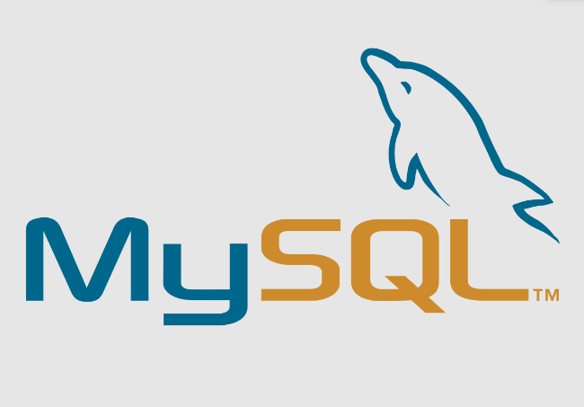
BBA STUDENT

Introduction
Netflix Originals have become a significant part of the global entertainment landscape, offering a diverse range of movies, series, and documentaries. Understanding the trends, viewer preferences, and quality of content within these Originals is crucial for content creators, marketers, and data analysts. By analyzing key attributes such as IMDb scores, genres, and runtimes, this project aims to uncover valuable insights into the performance and reception of Netflix Original content. Leveraging SQL for data querying and analysis provides a practical approach to extracting meaningful patterns from the datasets, which can inform strategic decisions and improve content curation.

Objective
The objective of this project is to analyze the Netflix Originals dataset using MySQL queries to extract meaningful insights and trends. Through this analysis, various SQL operations such as GROUP BY, HAVING, ORDER BY, LIMIT, JOINS, WINDOW FUNCTIONS, and SUBQUERIES are applied to understand viewer preferences, genre performance, and overall content quality.

Dataset Description:-
- Netflix_Originals: Contains detailed information about Netflix Originals including title, genre ID, runtime, IMDb score, language, premiere date, etc.
- Genre_Details: Contains genre ID and genre name mappings.

Methodology
This project uses SQL-based data analysis techniques to explore and derive insights from the Netflix Originals dataset. The following approach was taken:
- Data Preparation:
The two datasets—Netflix_Originals and Genre_Details—were joined using the genre_id field to combine title information with genre names.
- Aggregation and Grouping:
Aggregate functions such as AVG() and COUNT() were used along with GROUP BY to calculate metrics like average IMDb scores and count of titles per genre.
- Filtering Data:
The HAVING clause was applied to filter grouped data based on conditions like minimum average IMDb score or minimum count of titles meeting a score threshold.
- Ordering and Limiting Results:
To identify top entries, the ORDER BY clause was used to sort data by IMDb scores or runtime, and LIMIT was applied to restrict output to the top N results.
- Ranking Within Groups:
Window functions such as RANK() or ROW_NUMBER() partitioned by genre were used to rank Netflix Originals based on their IMDb scores within each genre.
- Subqueries:
Subqueries helped compare individual IMDb scores against the overall average IMDb score for all Netflix Originals, enabling identification of above-average titles.
This structured SQL approach allowed for a comprehensive analysis of Netflix Originals’ content quality, genre performance, and runtime trends.

Analysis and results

!.Whatare the average IMDb scores for each genre of Netflix Originals?
QUERY:-
SELECT g.GENRE,AVG(n.IMDBSCORE) AS average_imdb_score
FROM netflix_originals n
JOIN genre_details g ON n.GENREID = g.GENREID
GROUP BY g.GENRE
ORDER BY average_imdb_score DESC;
RESULT:-

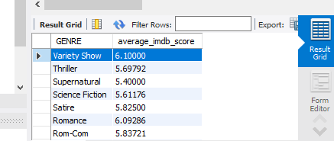

2.Which genres have an average IMDb score higher than 7.5?
QUERY:-
SELECT g.genre, avg (n.IMDBSCORE)AS Highest_average_imdb_score
FROM netflix_originals n
JOIN genre_details g ON n.GENREID = g.GENREID
GROUP BY g.GENRE
HAVING avg (n.IMDBSCORE)>7.5;
RESULT:-
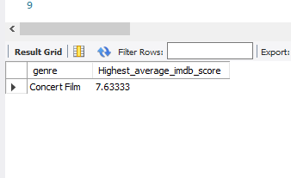

3. List Netflix Original titles in descending order of their IMDb scores?
QUERY:-
SELECT TITLE,IMDBSCORE FROM NETFLIX_ORIGINALS
ORDER BY IMDBSCORE DESC;
RESULT:-
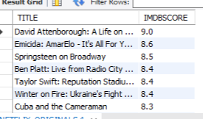

Retrieve the top 10 longest Netflix Originals by runtime.
QUERY:-
SELECT GENREID,RUNTIME FROM NETFLIX_ORIGINALS
ORDER BY RUNTIME DESC LIMIT 10;

RESULT:-
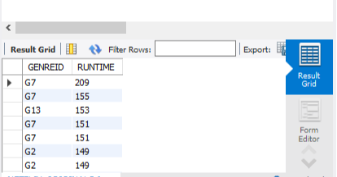

Retrieve the titles of Netflix Originals along with their respective genres
QUERY:-
SELECT
N.Title,
G.Genre_Name
FROM
Netflix_Originals AS N
JOIN
Genre_Details AS G
ON
N.Genre_ID = G.Genre_ID;
RESULT:-
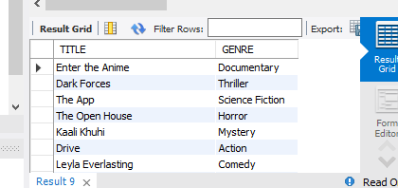

- RankNetflix Originals based on their IMDb scores within each genre
QUERY:-
SELECT
no.title,
gd.genre,
no.imdbscore,
DENSE_RANK() OVER (PARTITION BY gd.genre ORDER BY no.imdbscore DESC) AS imdb_rank_in_genre
FROM
netflix_originals no
JOIN
genre_details gd ON no.genreid = gd.genreid;
RESULT :-

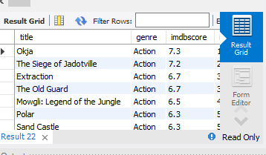

Which Netflix Originals have IMDb scores higher than the average IMDb score of all titles?
QUERY:-
SELECT TITLE,GENREID, IMDBSCORE AS HIGHER_SCORES FROM NETFLIX_ORIGINALS WHERE IMDBSCORE>(SELECT AVG(IMDBSCORE)FROM NETFLIX_ORIGINALS);
RESULT:-

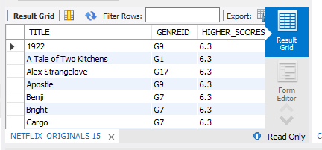

- How many Netflix Originals are there in each genre?
SELECT g.genre ,count(*) as .total_titles from
netflix_originals n
JOIN
genre_details g ON n.genreid = g.genreid
GROUP BY g.genre
ORDER BY
total_titles DESC;
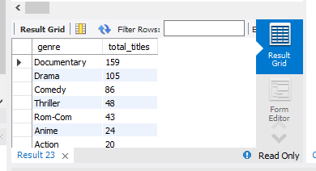

Which genres have more than 5 Netflix Originals with an IMDb score higher than 8?
QUERY:-
SELECT GENREID, COUNT(*) AS HIGH_RATED_TITLES
FROM NETFLIX_ORIGINALS
WHERE IMDBSCORE > 8
GROUP BY GENREID
HAVING COUNT(*) > 5
ORDER BY HIGH_RATED_TITLES DESC;
RESULT:-

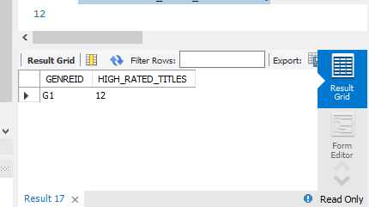

Whatare the top 3 genres with the highest average IMDb scores, and how many Netflix Originals do they have
QUERY:-
SELECT
G.Genre_Name,
ROUND(AVG(N.IMDb_Score), 2) AS Avg_IMDb_Score,
COUNT(N.Title) AS Total_Originals
FROM
Netflix_Originals AS N
JOIN
Genre_Details AS G
ON
N.Genre_ID = G.Genre_ID
GROUP BY
G.Genre_Name
ORDER BY
Avg_IMDb_Score DESC
LIMIT 3;
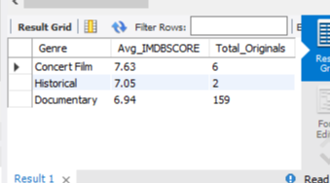

KEY INSIGHTS:-
After analyzing the dataset of Netflix Originals, several insights were observed:
- Average IMDb Scores by Genre:
The analysis shows how each genre performs in terms of audience ratings. Genres such as Documentary and Drama generally have higher IMDb scores compared to Comedy or Romance.
- Genres with High Average Ratings:
The Concert Film genre has the highest average IMDb score (7.63), followed by Historical (7.05) and Documentary (6.94).
This shows that audiences appreciate factual, artistic, and educational genres.
- Top-Rated Titles:
When ranked by IMDb scores, Netflix Originals show consistent quality in genres like Drama and Documentary, with several titles exceeding the platform-wide average rating.
- Runtime Analysis:
The longest Netflix Originals are mostly dramas.
- HIGH RATED TITLES:-
- Documentries has more than 5 Netflix Originals with an IMDb score higher than 8.
- High IMDb Scoring Titles:
Multiple titles have IMDb scores higher than the dataset average, proving Netflix’s consistent delivery of well-rated Originals.

Conclusion:-
The analysis highlights that Netflix’s strongest genres are Concert Films, Historical, and Documentaries, based on average IMDb ratings.
While Documentary has the largest volume of Originals, Concert Film content receives the highest audience appreciation.
This suggests that Netflix should continue investing in quality factual and cultural content, while also enhancing viewer engagement in other genres to improve their overall IMDb performance.

REFERENCE :-

NETFLIX DATASET -INTERNSHALA
INTERNSHALA TRAINING COURSE CONTENT

